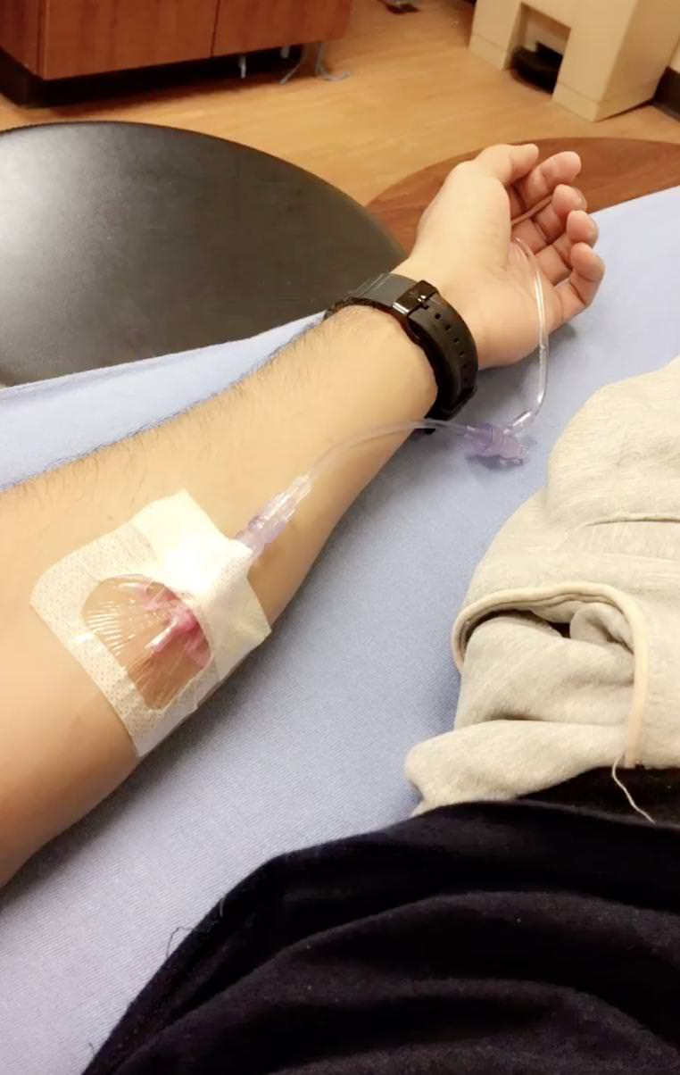
The photo above shows an individual who is being immunized against a disease; Public health aims at preventing infections, ensuring the good human health and also prolonging the life of human beings. This photo is therefore related to public health in all those aspects; this acts done through informed choices, and efforts of the individual and also to a large extent the society.

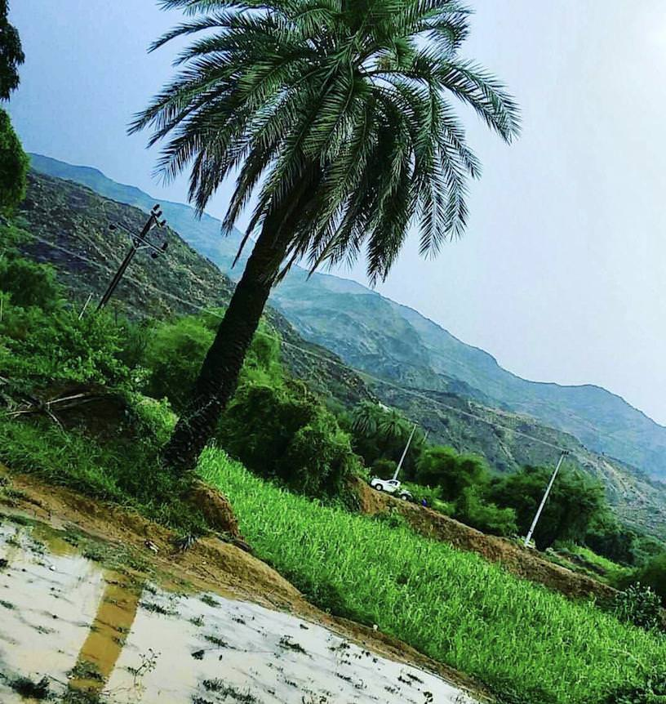

Public health works towards protecting and promoting good health of individuals in the societies in which they co-exist, play and work. This, therefore, means that public health prevents individuals in the community from contracting any sickness and this is promoted by ensuring that people exercise healthy behaviors such as cleaning the immediate environment. In the photo above the area has been neglected and this poses a great danger to the people living around as it a breeding ground for mosquitos, this is not an healthy behavior, and therefore it is related to public health.

